Project Design Phase-II Technology Stack (Architecture & Stack)

|  |  |
| --- | --- |
| Date | 28 June 2025 |
| Team ID | LTVIP2025TMID50749 |
| Project Name | Visualizing Housing Market Trends: An  Analysis of Sale Prices and Features using Tableau |
| Maximum Marks | 4 Marks |

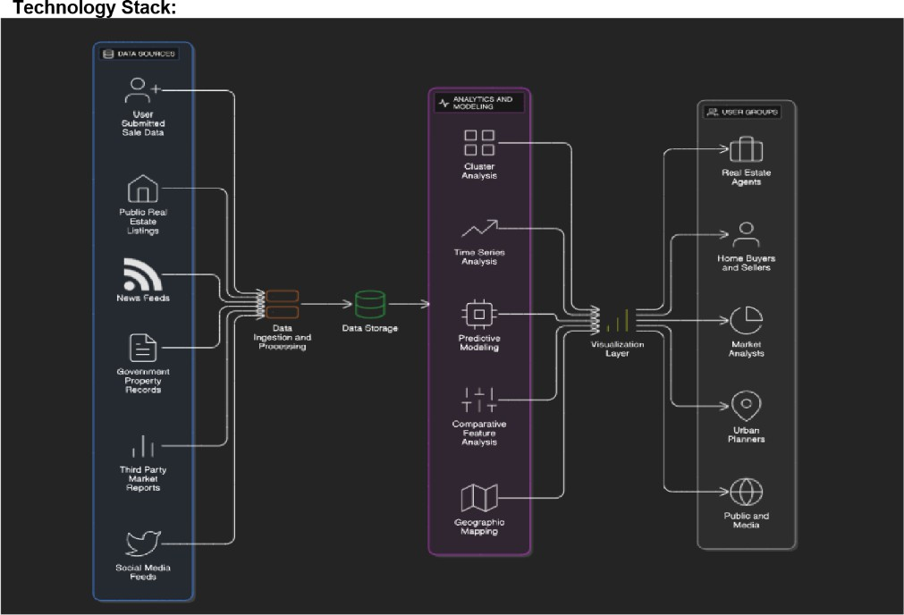

References:

<https://c4model.com/>

<https://developer.ibm.com/patterns/online-order-processing-system-during-pandemic/> <https://www.ibm.com/cloud/architecture>

<https://aws.amazon.com/architecture>

<https://medium.com/the-internal-startup/how-to-draw-useful-technical-architecture-diagrams-2d20c9fda90d>